//Code

To find the factorial of a number using recursion

#include<stdio.h>

int fact(int );

int main(){

int n,factorial;

printf("Enter the number\n");

scanf("%d",&n);

factorial=fact(n);

printf("The factorial is %d",factorial);

return 0;

}

int fact(int n){

if(n==1)

return 1;

else

return (n\*fact(n-1));

}

Output:  
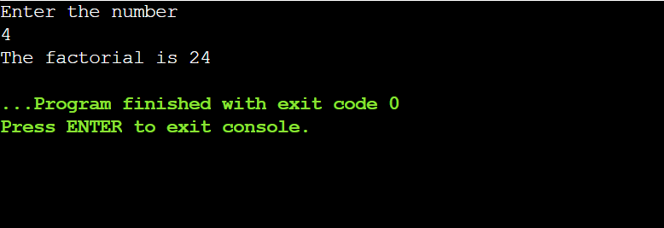

Conclusion: C program to compute factorial of a number using recursion was implemented successfully.